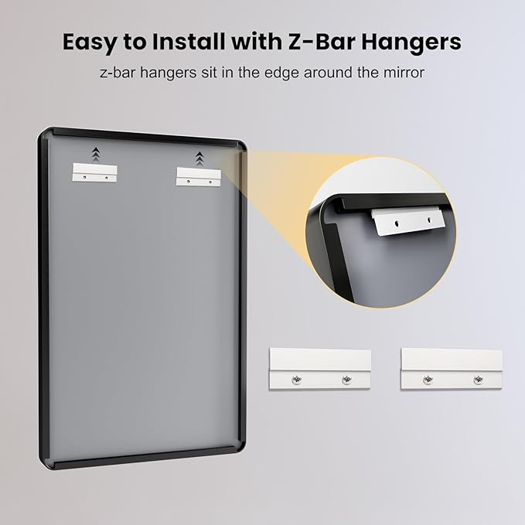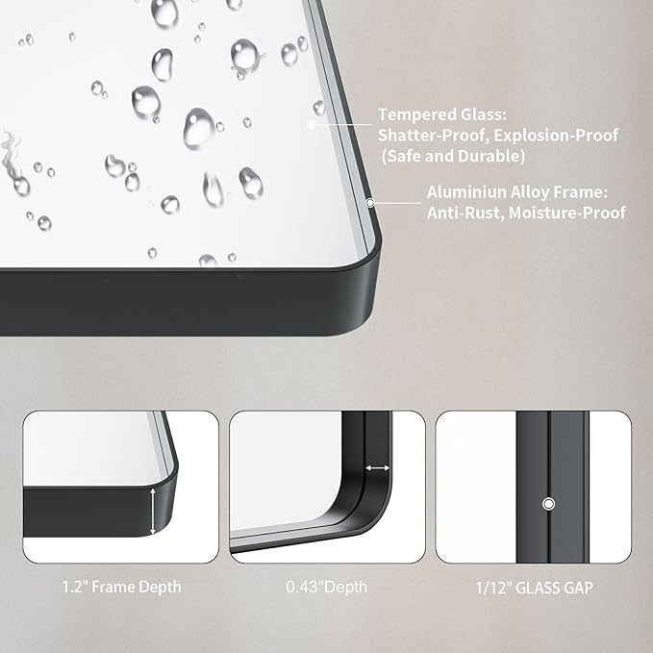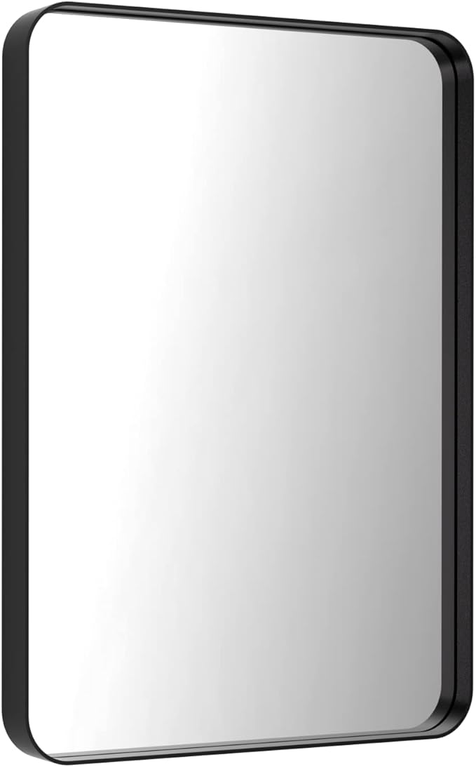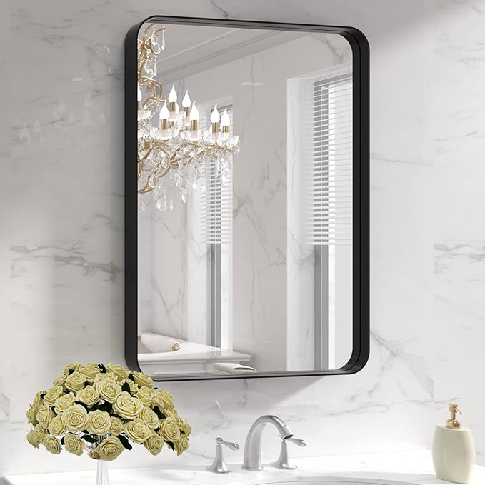

LOAAO Black Metal Framed Bathroom Mirror for Wall, 22X30 Inch Rounded Rectangle Mirror, Matte Black Bathroom Vanity Mirror Farmhouse, Anti-Rust, Hangs Horizontally or Vertically

**PRODUCT DESCRIPTION:**

|  |  |
| --- | --- |
| Brand | LOAAO |
| Room Type | Bathroom |
| Shape | Rectangular |
| Product Dimensions | 30"L x 22"W |
| Frame Material | Aluminum  **About this item**   * Black Metal Tempered Glass Mirror * 【Clear Reflection & NO Distortion】: LOAAO bathroom vanity mirror is designed with HD float glass to deliver a clear reflection with no distortion; clear lines; simple modern design * 【Sturdy Mirror with Premium Materials】: LOAAO black metal mirror with aluminum alloy frame which is anti-rust; and also the metal-framed mirror is built with explosion-proof membrane which ensure the mirror being safely and securely for using * 【Secure & Easy Hanging Option】: The sturdy wall mirror includes two Z-bar brackets; The brackets are sturdy enough to support the weight of the mirror and ensure the mirror stay securely and sturdily against the wall; Very easy to install * 【Safe & Secure Package】: The package for this wall mounted bathroom mirror is well and securely designed with all-around protective Styrofoam with passed drop test; no worry about the breakage * 【Wide Application】: A ideal contemporary mirror for wall decor with brushed metal frame, classic, perfectly goes with any decor; Suitable for using in bathroom, vanity, farmhouse, bedroom, living room, dinning room, entryway, fireplace |